1. Write a SQL query to find books which titles start with “The”. Order the result by id. Submit your query statements as Prepare DB & run queries.

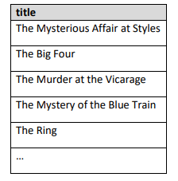

1. Write a SQL query to find books which titles start with “The” and replace the substring with 3 asterisks. Retrieve data about the updated titles. Order the result by id. Submit your query statements as Prepare DB & run queries.

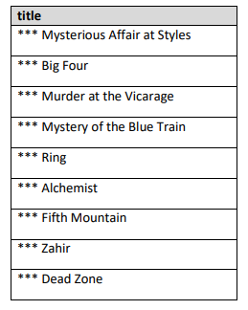

1. Write a SQL query to sum prices of all books. Format the output to 2 digits after decimal point. Submit your query statements as Prepare DB & run queries.
2. Write a SQL query to calculate the days that the authors have lived. NULL values mean that the author is still alive. Submit your query statements as Prepare DB & run queries.

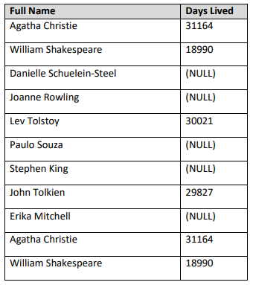

1. Write a SQL query to retrieve titles of all the Harry Potter books. Order the information by id. Submit your query statements as Prepare DB & run queries.

